The Lancet Countdown in Europe:

Tracking Progress on Health and Climate Change



New Indicator White Paper [Template]

Contributors: Zachary Dickson

Working group: 5

Topic: Political Party Positions on Climate Change Policies

Indicator White Paper [Template]
This template white paper document is to be used for the Assessment Process of all new indicators and both current European (i.e., those included in the 2024 report) and global (i.e., those included in previous iterations of the global report) indicators proposed for the Lancet Countdown in Europe for consideration for the 2026 report. The white paper should contain as much technical detail as possible, but should be no more than 6 pages long (excluding appendix and references). Indicator white papers should be reviewed through this mechanism before the data collection and processing has begun. However, to enable an accurate assessment, authors are asked to provide a mock sample of how the indicator would be reported.
Submission deadline is 17 January 2025 23:59 CET.
Please submit your indicator white paper to your working group lead and cc Hedi Kriit (hedi.kriit@uni-heidelberg.de) and Joacim Rocklöv (joacim.rockloev@uni-heidelberg.de), and add to the “2026 White Papers” folder on the Lancet Countdown in Europe Dropbox of the working group of relevance.
Please ensure all indicator proposals are discussed before submission of the white paper with the WG lead and with the Lancet Countdown central team representatives.
Feedback will be shared by 04 March 2025 23:59 CET.
For further information or any questions, please contact Hedi Katre Kriit hedi.kriit@uni-heidelberg.de
Working group leads:
WG1 Prof. Joacim Rocklöv joacim.rockloev@uni-heidelberg.de,
WG2 Prof. Jan Semenza, jan.semenza@lateralPHC.com,
WG3 Prof. Cathryn Tonne cathryn.tonne@isglobal.org,
WG4 Prof. Anil Markandya anil.markandya@bc3research.org,
WG5 Prof. Slava Jankin v.jankin@bham.ac.uk and Prof. Niheer Dasandi n.dasandi@bham.ac.uk

Please read indicator and authorship criteria below before filling in the White Paper:
- Indicator criteria for the Lancet Countdown Europe
- Authorship criteria

Description of the indicator
  - Indicator Name

Political Party Positions on the Nexus of Health and Climate Change Policies
  - Which working group is it suggested for (and sub-topic, if relevant)?
Please find the most recent list of working groups and topics in the panel in 2024 Europe report.
WG 5
  - Which aspect of the relationship between climate change and health in Europe does this indicator track? Describe the evidence available to back this relationship, as published in the scientific literature (e.g. systematic reviews), and the suitability of the proposed indicator in tracking it
The proposed indicator tracks policy positions on the nexus between health and climate change for European political parties. A key challenge to mitigating the public health consequences of climate change remains electing parties and leaders who prioritize policies that reduce the impact of climate change. This indicator will allow voters and stakeholders to understand parties’ policy positions on health and climate change over time and across regional and country contexts.

The indicator will address the nexus between health and climate change from two angles. First, the indicator will include party positions according to party manifestos. Manifestos represent parties’ programmatic policy positions and therefore include official stances on salient political issues. Second, the indicator will leverage parties’ press releases published through official party channels. Party press releases are used to respond to societal changes and current events, and are published more frequently than manifestos. The combination of the two sources will provide a comprehensive view of party positions on the intersection of climate change and health.

  - How will the indicator fit within the scope of the working group and in what ways does it relate to exciting indicators, and its contribution in the field of climate change and health in Europe (i.e. which research gap in Europe does it fill), and what is its relevance for European policy? Please describe how does your indicator relate to other topics in the report (e.g. adaptation, mitigation, economics and engagement).
The current report lacks an indicator for tracking political party positions on health and climate change policies. Given that a key hurdle to adopting expansive climate change policies and therefore addressing the public health consequences of climate change is political, this indicator will fill a critical gap in the report. This indicator will allow for benchmarking of party positions on health and climate change policies across countries and over time, and will provide a critical tool for understanding the political landscape of health and climate change policy in Europe.

  - What metric does the indicator track? Indicate its units (e.g. This indicator reports on the greenhouse gas emissions associated with food consumption in tCO2 equivalent per person)
The indicator tracks party positions on health and climate change policies. The metric is a score from 0 to 1, where 0 indicates that the party does not associate public health with the consequence of climate change, while 1 indicates that public health is always seen as a function of climate change. These scores will be based on a scaling method that uses large language models applied to political party manifestos and party press releases (see Dickson & Hobolt (2024) for more information on a similar method).
  - What geographies or socioeconomic groups will this indicator be relevant to?
This indicator will include all EEA+EFTA+UK countries.

3.7 Has this proposed indicator been published previously as part of the global Lancet Countdown or is similar to an indicator in the global Lancet Countdown? If applicable, describe the similarities and differences (i.e., data sources, in methodology) between the proposed indicator and the indicator published in the global report.

This indicator has not been published previously as part of the global Lancet Countdown.

3.8 Please highlight the relevant between-country and within-country (i.e., social, vulnerable populations) inequalities (disparities) related to the outcome of the indicator. Please include references to relevant scientific literature. These could be related to differences among populations (i.e., vulnerable populations) in 1) exposure to climate hazards, 2) susceptibility to damage caused by climate hazards, and 3) ability to cope with and recover from damage. For indicators reporting on mitigation and adaptation this could, for example, also include a discussion on differences in historical and current GHG emissions.

NA

Description of the data
  - Describe the datasets that will be used in the development of this indicator method of collection, and strengths and potential limitations or biases.
This indicator will use political party manifestos and official party press releases to identify parties' positions on health and climate change policies. Political Party Manifestos include the party's policy platform and contains the party's explicit positioning on different issues and policies. The data will be collected from the Manifesto Project (Lehmann et al. 2024), which collects and codes political party manifestos from around the world. The second source of data for the indicator will be official party press releases. These data will come from political parties’ official communication channels, often via parties’ websites.

The proposed indicator will apply a machine learning method similar to the one developed in Dickson & Hobolt (2024) that will position parties on health and climate change using large language models based on their communication. The main strength of this indicator is that it will provide a comprehensive and systematic way to track party positions on health and climate change policies across countries and over time.

  - Please indicate the temporal (i.e., start and end date of the data) and geographical coverage of the datasets used.
The data will cover the period from 2015 to 2024 and will include parliamentary parties in EEA+EFTA+UK countries.

________________________________________________________________________________
  - Please indicate the frequency with which the database is updated
The proposed indicator will be updated annually to reflect the most recent data available.
  - Are the proposed input data included in the list of the Lancet Countdown’s preferred datasets? If they are not, please justify the choice
The dataset does not appear to be included in the list of the Lancet Countdown's preferred datasets. However, the Manifesto Project is a widely used and respected source of data on political party manifestos. Moreover, the underlying data are provided directly by political parties, which ensures that the data are accurate and can be maintained in the case that the Manifesto project ceases to exist. Additionally, party press releases are available via parties’ official websites.
  - Does the data allow this indicator results to be stratified across (vulnerable) population subgroups, please specify. For example, by: sex or gender, socio-economic status (e.g. education, income, occupation), racial or ethnic groups, age (e.g. children, elderly), people with disabilities, migrants, asylum seekers and refugees). If not possible, please explain why.
The data will allow for stratification by country, which will allow for comparisons across countries and over time. The data will not allow for stratification by other population subgroups.
4.6 Other than stratification, are there ways in which your indicator is able to account for between-country and within-country inequalities (i.e., vulnerable populations)? If your indicator is not able to account for this, please specify why.
The indicator will not account for between-country and within-country inequalities.

Description of the methodology

  - Provide details of the data analysis process, assumptions made and any statistical tests used to analyse and derive conclusions from the data. Provide details of the scientific literature supporting its use and suitability for tracking this aspect of the relationship between climate change and health, if available. If the methodology has not been reported in the published scientific literature, please provide a detailed description on how the methodology was derived and validated.

The proposed indicator will use a machine learning method to position parties on health and climate change policies using large language models based on their expressed positions in party manifestos and in official press releases. This method has been validated in several recent publications (Dickson & Hobolt 2024; Le Mens & Gallego 2025). Treating each document as a single observation, the text will go through a series of binary classification procedures that form a larger hierarchical decision tree intended to sort the documents into different categories. The tree structure is as follows:

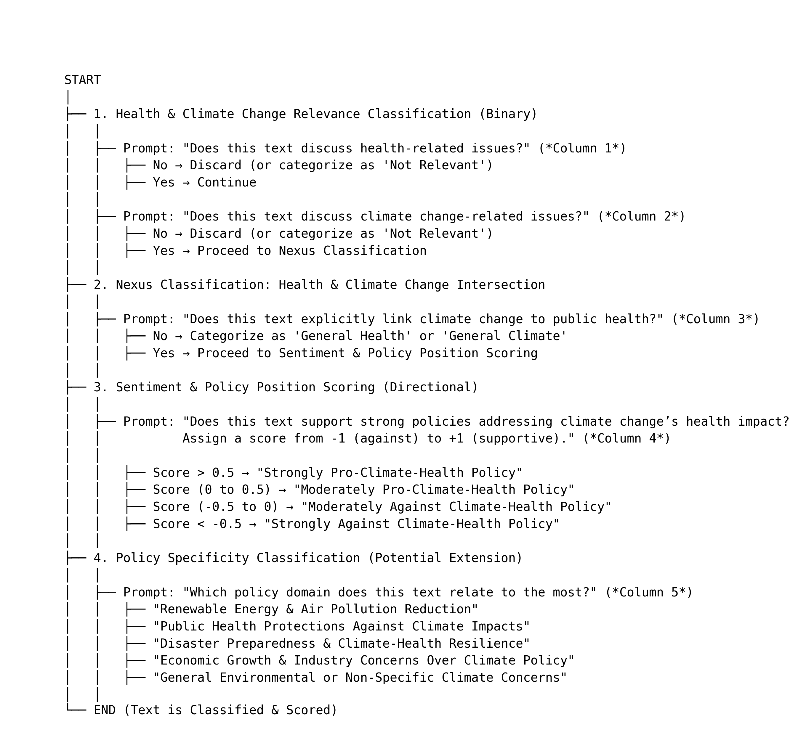

At each hierarchical category, a new column will be created as part of the classification. This will result in a maximum total of 5 columns for each observation. Once scoring is completed, the data will be aggregated by party and date. The mean value for the aggregated data for the prompt ‘Does the text explicitly link climate change to public health’ will capture the nexus of climate change and public health. This value will reflect the documents that address the nexus as a proportion of the total number of documents, reflecting the amount of ‘attention’ designated to the climate change and health policy (Dickson 2024).

Validation of the methodology will include the hand-coding of a random sample of 1000 documents. Precision, recall, and F1 score will be calculated by comparing the hand coded documents to the predicted scores by the LLM.

  - Geographical coverage: which European countries will this indicator cover and provide data for? (e.g., EU-27, EEA-38, WHO European Region-53). Note, the Lancet Countdown in Europe aims to include at least the 38 European Environment Agency members and cooperating countries and the United Kingdom.
The indicator will cover EEA+EFTA+UK countries.
  - What is the finest geographical resolution at which this indicator can be developed (e.g., gridded and/or administrative data: NUTS3/NUTS2/NUTS1 level, country, sub-regional, regional)?

The indicator will be developed at the country level, for each political party within the country.

  - Will (or can) the reporting of this indicator include a stratification of results by European country groupings (i.e., Eastern, Northern, Southern, Western Europe) as defined by the UN geoscheme for Europe?
Yes, the indicator will allow for stratification by country, which will allow for comparisons across countries and over time.

  - Which years will the indicator provide data for (please indicate start and end date)?
The indicator will provide data for the period from 2015 to 2024.
  - Can this indicator provide annual updates, providing an extra year of data for each iteration of the report? If not, how frequently will it be updated?
Party Manifestos are often made available around a country's national elections, which do not necessarily occur in each country, each year. However, party press releases are more frequent and will allow for updates each year. In combination, the indicator will provide new information for each party, each year.
  - Provide a mockup of how the indicator will be reported. This could be a small sample of the indicator for a few countries or years,or a mock graphic. Please also provide a sentence for how the indicator will be communicated (e.g. “deaths attributable to air pollution increased by XX%, from XX to XX deaths from 1986 to 2020”)
Year X
Country A
Party 1: 0.5
Party 2: 0.2
Party 3: 0.8
Country B
Party 1: 0.4
Party 2: 0.7
Party 3: 0.1
Country …

Year …

Indicator caveats and future improvements
  - Describe any caveats of the indicator in its current form.

The primary limitation of the indicator is that it will rely on current political practices being carried into the future, given its reliance on published political communication. Current practices are not expected to change.

  - What are the possibilities of overcoming these limitations in the future? Provide a timeline detailing how this indicator will be improved in subsequent years.

The indicator can be improved in subsequent years by expanding the dataset to include more countries and parties. The indicator can also be improved by refining the machine learning method used to position parties on climate change policies. The timeline for these improvements will depend on the availability of data and resources.

6.3 What are the strengths of the indicators in its current form?

The primary strength of the indicator is that it will provide a comprehensive and systematic way to track party positions on health and climate change policies across countries and over time. The indicator will also provide a critical tool for understanding the political landscape of the nexus between health and climate change policy in Europe and will allow for benchmarking of party positions on this vital intersection.

6.4 If your indicator is an update of an indicator in the 2024 Lancet Countdown in Europe report, please specify whether any changes have been made to improve the indicator. For example, this can be methodological, data or spatial-temporal coverage improvements.

NA

6.5 We would like to ensure continuation of the indicators in the report, if your indicator was to be accepted. Please present a succession plan for your indicator so that the indicator could be included annually for at least 4 consecutive years.

The indicator will be updated annually for at least four consecutive years and can likely have a greater time horizon if desired.

Appendices

References
Dickson, Zachary P., and Sara B. Hobolt. "Going against the grain: Climate change as a wedge issue for the radical right." Comparative Political Studies (2024):
Dickson, Zachary P. "The Gender Gap in Elite-Voter Responsiveness Online." Perspectives on Politics (2024): 1-17.
Le Mens G, Gallego A. Positioning Political Texts with Large Language Models by Asking and Averaging. Political Analysis. Published online 2025:1-9. doi:10.1017/pan.2024.29
Lehmann, Pola / Franzmann, Simon / Al-Gaddooa, Denise / Burst, Tobias / Ivanusch, Christoph / Regel, Sven / Riethmüller, Felicia / Volkens, Andrea / Weßels, Bernhard / Zehnter, Lisa (2024): The Manifesto Data Collection. Manifesto Project (MRG/CMP/MARPOR). Version 2024a. Berlin: Wissenschaftszentrum Berlin für Sozialforschung (WZB) / Göttingen: Institut für Demokratieforschung (IfDem). https://doi.org/10.25522/manifesto.mpds.2024a

